### **DECISION ANALYSIS FOR MANAGERS**

### **PROJECT**

### **Case Solution Document**

### ***Submitted to:***

### **Dr. Gajanand M S**

### 

### ***Submitted by:***

### **PGPM 2023-2025**

### **Group 1 - Team 5**

|  |  |
| --- | --- |
| **Angelin Sara Jacob** | **2301165** |
| **Nanditha Krishna Kumar** | **2301116** |
| **Rupaa Shri S** | **2301124** |
| **Rohith S V** | **2301365** |
| **Thariq Mohammed** | **2301382** |

### 

### **BUSINESS PROBLEM STATEMENT**

Integrity Shippers, a leading logistics company in India, is at a critical strategic decision point: how to sustain growth and enhance shareholder value through international expansion. The company’s leadership is considering three potential markets—Dubai, the United States, and Canada—for global expansion. Each market presents distinct opportunities and challenges in terms of market favorability, regulatory environments, workforce availability, and associated costs. The key business problem is determining which of these markets offers the optimal balance of growth potential, strategic alignment, and manageable risks.

**TOOLS USED:** Microsoft Excel, Oracle Crystal Ball Add-In, Decision Tree add in  
  
**ASSUMPTIONS:**

* Constant 14% interest rate can be assumed across all forecast years for all the 3 alternatives.
* Constant 30% corporate tax rate across all regions for all forecast years for all the 3 alternatives.
* 15% of the net income generated in India would be the projected net income for Year 1 in whichever region Integrity Shippers chooses to expand.

**METHODOLOGY:**

1. Develop a decision tree to identify which country to expand among the alternatives
2. Identify the factors that affect the expansion into a country and their corresponding probability and payoff matrix
3. Use CrystalBall Simulation to estimate the possible payback period.

**CASE QUESTIONS:**

1. What is the optimal sequence of decisions?
2. How sensitive is the outcome to changes in key factors?
3. Which Market Provides the Best Long-term Strategic Position?
4. What will be the projected net income for the next 10 years starting from April 2025?
5. How net income generated from new location gets adjusted for inflation?
6. What will be the future cash flows over the projected period?
7. What is the estimated payback period for the optimal market?

**RESULTS AND ANALYSIS:**

Sensitivity graphs

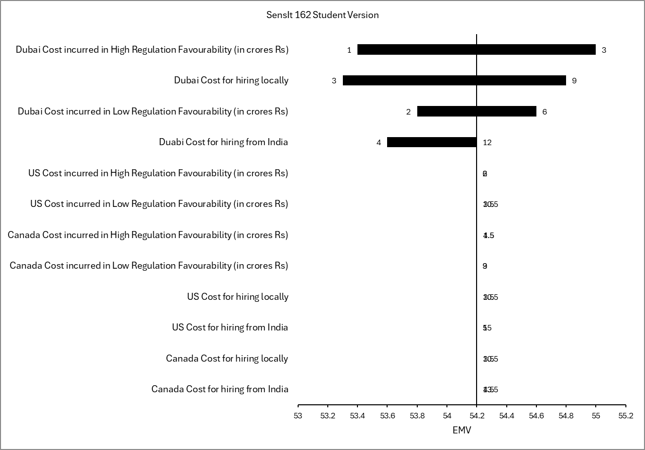

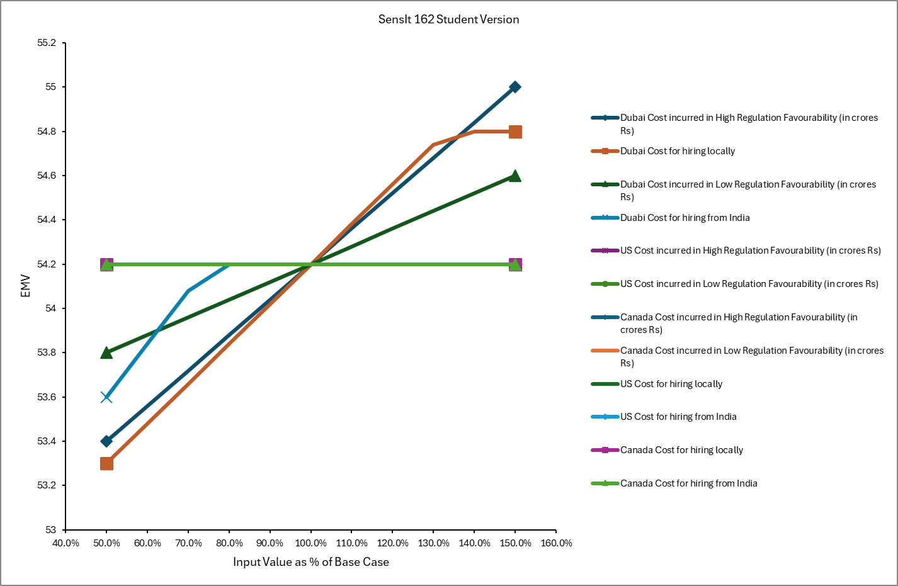

Forecast graph

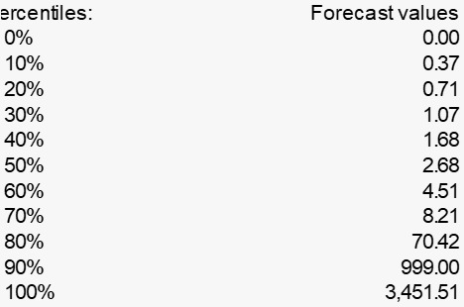

**INSIGHTS AND FINAL RECOMMENDATIONS:**

1. From the sensitivity analysis, it can be observed that within Dubai, the decision to hire employees locally or from India affects the payoff the most.
2. 70% chance to breakeven within 9 years.